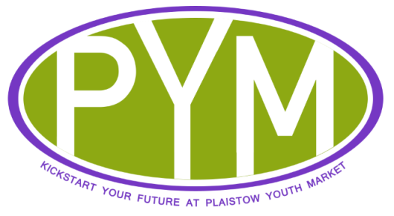
MARKET AGREEMENT- PYM
We encourage high professional standards and customer care. Stallholders are individually responsible for the quality of their goods and behaviour – PSBL cannot accept any liability. When traders are given a PYM license they are agreeing these terms and conditions, including the following key standards:
- All goods should be handmade
- All goods should be priced. Prices should be clear and visible.
- Any descriptions applied to goods should be accurate.
- All goods should be safe. No electrical goods can be sold. Particular care should be taken over food and goods intended for children such as toys, which should be labelled for appropriate age range.If selling food products, please ensure they are prepared according to food hygiene standards and stored appropriately throughout the event. There will not be electrical power available on site. Please include details of any potential allergens in food produce as this is a legal requirement. Each stallholder is responsible for the hygiene and safety of goods they sell.
- You must not sell counterfeit, pirate or other illegal goods.
- Members of the public must be treated fairly and with courtesy. Derogatory or discriminatory behaviour will not be tolerated and will result in removal from the stall.
- All traders have to finish setting up by 10:30 am when they need to attend a health and safety briefing. All stall holders to adhere to health and safety procedures.
- Stall holders are responsible for keeping stalls clean and tidy and disposing of all rubbish in bin bags provided.
- No traders should consume alcohol, use illegal drugs or smoke whilst operating a PYM stall.
- The market does not accept responsibility for loss, theft or damage of any goods or personal property.
- You should ensure you bring enough money change appropriate to your pricing structure – the organizers will not have a supply of change available.
PSBL is a not-for-profit organisation operating under the remit of REIN, 478 Barking Road, E13 8QB. Please cooperate with the organiser and helpers on the day – most of them are volunteers. By signing this agreement you also agree to photographs being taken on the day and used in PSBL publicity.
The Plaistow Youth Market committee will provide each stall holder with:
- A shared gazebo structure, table (at least 1.2m x 0.6m)and table covering, to use for trading
- Market security
- Access to toilet facilities
- Money pouch on loan for the event
- Bags for litter
- A trader ID pass
- A briefing about Health & Safety issues

Please note goods have to be handmade by Licence holder and other applicants.
Please note stallholders have to setup and pack away the gazebo and tables provided. Please arrive by 9am to have enough time to do so.
Not complying with this agreement will not be tolerated and will result in withdrawal of licence.
Please now complete the details overleaf
Today’s date: How did you hear about PYM?
- YOUR DETAILS

- Name of licensed stallholder: (please attach proof of DOB)
- Other applicants (if any):
- Date of birth: (please attach proof of DOB)
4. Address: (Please attach proof of address)
5. Telephone Number (mobile or landline):
6. E-mail address:
YOUR STALL
- A name for your business:
- Social media if any
- What products/services/skills will you be selling?
(Please attach appropriate certification for food or cosmetic products, example: Food safety level 2 or Safety assessment for cosmetics.)
Food Hygiene Certificate Number (if applicable):

- DECLARATION
I confirm that the information given above is correct to the best of my knowledge.
I am available and, if my application is accepted, will commit to run a stall as described above for the duration of the market (9:00 am-4 pm) Please let us know wish of the 6 markets you wish to attend. (Example put Y for market that you wish to attend and N for the ones you are not sure yet) You can amend your answers 3 weeks before each market.
April 6th Greenway- Y/N May 4th Greenway- Y/N June 1st Greenway- Y/N
July 6th Greenway- Y/N August 3rd Greenway- Y/N September 7th Greenway- Y/N
Please attach to this agreement proof of ID (to determine age of applicant), proof of address (this services are available for local residents only), food safety certificate if you sell food.
Please note over 30’s pays £10 for their stall.

Signed:

Please return the completed form to: lora@plaistowsouthbiglocal.org.uk
or PSBL, c/o REIN, 478 Barking Road, E13 8QB
Create It. Bring It. Sell It.@

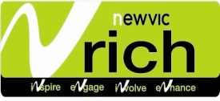
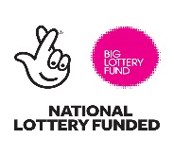
in partnership with:
Rights & Equalities in Newham

